**M. Ali. Arslan**

**19F-0348**

**Assignment-01**

**Link List**

**Task # 01**

#include<iostream>

#include<iomanip>

using namespace std;

struct node

{

int data;

node* previous_node;

node* next_node;

};

class double_list {

public:

node* head;

node* tail;

int count;

double_list()

{

head = tail = NULL;

count = 1;

}

void insertion(int value)

{

node* new_node = new node;

new_node->data = value;

new_node->next_node = NULL;

new_node->previous_node = NULL;

if (head == NULL)

{

head = new_node;

tail = new_node;

}

else

{

tail->next_node = new_node;

new_node->previous_node = tail;

tail = tail->next_node;

}

count++;

node* temp_1 = head;

node* temp_2 = head->next_node;

while (temp_1->next_node != NULL)

{

while (temp_2 != NULL)

{

if (temp_1->data > temp_2->data)

{

int temp_3 = temp_2->data;

temp_2->data = temp_1->data;

temp_1->data = temp_3;

}

temp_2 = temp_2->next_node;

}

temp_1 = temp_1->next_node;

temp_2 = temp_1->next_node;

}

}

void display()

{

node* temp_1 = head;

while (temp_1 != NULL)

{

cout << " " << temp_1->data;

temp_1 = temp_1->next_node;

}

}

void deletion(int node_number)

{

if (node_number == 1)

{

node* temp_1 = head;

head->next_node = temp_1->next_node;

head = head->next_node;

head->previous_node = NULL;

delete temp_1;

}

else if (node_number > 1 && node_number < count - 1)

{

node* temp_2 = head;

for (int i = 1; i < node_number; i++)

{

temp_2 = temp_2->next_node;

}

temp_2->previous_node->next_node = temp_2->next_node;

temp_2->next_node->previous_node = temp_2->previous_node;

delete temp_2;

}

else

{

node* temp_3 = tail;

tail->previous_node->next_node = NULL;

tail = tail->previous_node;

delete temp_3;

}

}

};

int main()

{

double_list a;

bool check = true;

int choice, value_1;

while (check)

{

cout << "1) Insert value" << endl;

cout << "2) Delete value" << endl;

cout << "3) Display the values" << endl;

cout << "0) Exit" << endl;

cout << "Enter choice: ";

cin >> choice;

cout << endl;

switch (choice)

{

case 1:

cout << "Enter a vlaue: ";

cin >> value_1;

a.insertion(value_1);

cout << endl;

break;

case 2:

value_1 = 0;

cout << "Enter node which you want to delete: ";

cin >> value_1;

a.deletion(value_1);

cout << "Value has been deleted from linklist " << endl;

cout << endl;

break;

case 3:

cout << "Link List is : ";

a.display();

cout << endl;

break;

case 0:

exit(0);

break;

default:

cout <<"Invalid Choice " << endl;

break;

}

}

system("pause");

return 0;

}

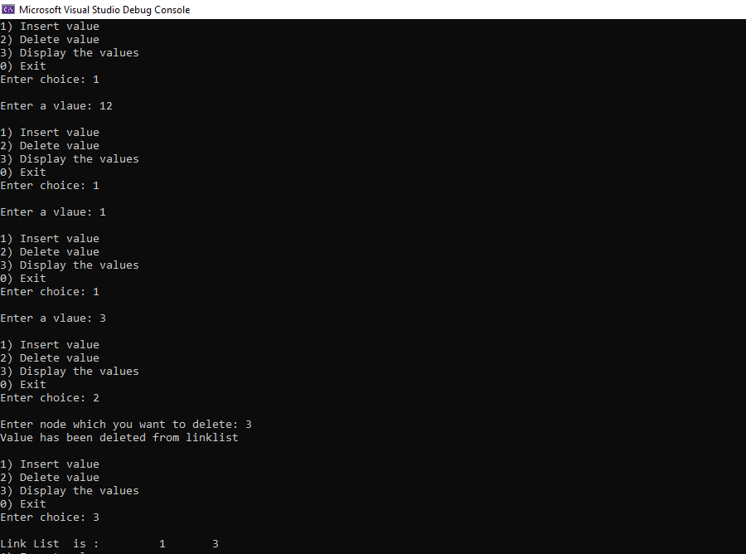

**Task # 02**

#include<iostream>

#include<iomanip>

using namespace std;

struct node

{

node* next;

int data;

};

class LinkedList

{

public:

node* head;

node* tail;

LinkedList()

{

head = tail = NULL;

}

void insertion(int value)

{

node* new_node = new node;

new_node->data = value;

new_node->next = NULL;

if (head == NULL)

{

head = tail = new_node;

}

else

{

tail->next = new_node;

tail = tail->next;

}

}

void display()

{

node* temp_1 = NULL;

temp_1 = head;

while (temp_1 != NULL)

{

cout << " " << temp_1->data << "->";

temp_1 = temp_1->next;

}

}

void swap(int first_node_value, int second_node_value)

{

node* first_ptr = head;

node* previous_of_first_ptr = NULL;

while (first_ptr != NULL && first_ptr->data != first_node_value)

{

previous_of_first_ptr = first_ptr;

first_ptr = first_ptr->next;

}

node* second_ptr = head;

node* previous_of_second_ptr = NULL;

while (second_ptr != NULL && second_ptr->data != second_node_value)

{

previous_of_second_ptr = second_ptr;

second_ptr = second_ptr->next;

}

if (previous_of_first_ptr == NULL)

{

head = second_ptr;

}

else

{

previous_of_first_ptr->next = second_ptr;

}

if (previous_of_second_ptr == NULL)

{

head = first_ptr;

}

else

{

previous_of_second_ptr->next = first_ptr;

}

node* temp_3;

temp_3 = second_ptr->next;

second_ptr->next = first_ptr->next;

first_ptr->next = temp_3;

}

};

int main()

{

LinkedList a;

bool check = true;

int choice, value_1, value_2;

while (check)

{

cout << "1) Insert value " << endl;

cout << "2) Enter node value you want to swap " << endl;

cout << "3) Display the values " << endl;

cout << "0) Exit" << endl;

cout << "Enter choice: ";

cin >> choice;

cout << endl;

switch (choice)

{

case 1:

cout << "Enter a vlaue: ";

cin >> value_1;

a.insertion(value_1);

cout << endl;

break;

case 2:

value_1 = 0;

cout << "\nEnter node value which you want to swap : ";

cin >> value_1;

cout << "\nEnter another node value which you want to swap : ";

cin >> value_2;

a.swap(value_1, value_2);

cout << "List has been swapped!" << endl;

break;

case 3:

cout << "Link List is: ";

a.display();

cout << endl;

break;

case 0:

exit(0);

break;

default:

cout << "Invalid Choice " << endl;

break;

break;

}

}

system("pause");

return 0;

}

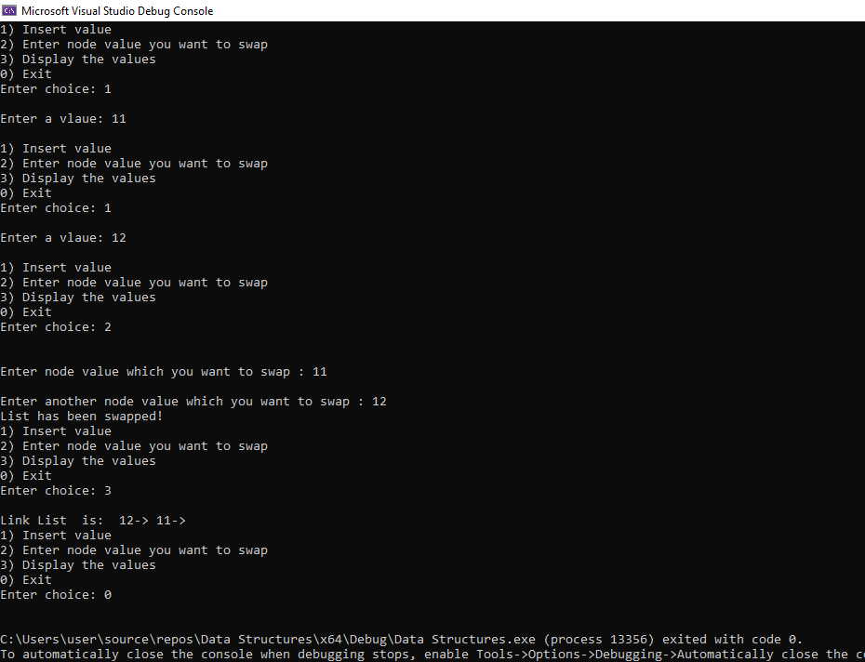

**Task # 03**

#include<iostream>

using namespace std;

struct Node

{

int data;

Node* next;

};

class LinkedList

{

public:

Node* head;

Node* tail;

LinkedList()

{

head = tail = NULL;

}

void insertion(int data)

{

Node* new_node = new Node;

new_node->data = data;

new_node->next = NULL;

if (head == NULL)

{

head = tail = new_node;

}

else

{

tail->next = new_node;

tail = tail->next;

}

}

void display()

{

Node* temp_1 = NULL;

temp_1 = head;

while (temp_1 != NULL)

{

cout << " " << temp_1->data << "->";

temp_1 = temp_1->next;

}

cout << endl;

}

void ReverseLinkList()

{

Node* current_ptr, * next_ptr, * previous_ptr = 0;

current_ptr = head;

next_ptr = head;

while (next_ptr != NULL)

{

next_ptr = next_ptr->next;

current_ptr->next = previous_ptr;

previous_ptr = current_ptr;

current_ptr = next_ptr;

}

head = previous_ptr;

}

};

int main()

{

LinkedList a;

a.insertion(0);

a.insertion(99);

a.insertion(33);

a.insertion(66);

cout << "LL before: ";

a.display();

cout << endl;

cout << "LL after: ";

a.ReverseLinkList();

a.display();

cout << endl;

system("pause");

return 0;

}

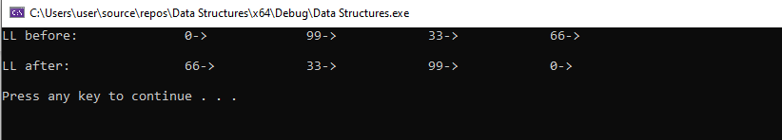

**Task # 04**

#include<iostream>

#include<iomanip>

using namespace std;

struct node

{

int data;

node* previous_node;

node* next_node;

};

class doubly_link_list {

public:

node* head;

node* tail;

doubly_link_list()

{

head = tail = NULL;

}

void insertion(int value)

{

node* new_node = new node;

new_node->data = value;

new_node->next_node = NULL;

new_node->previous_node = NULL;

if (head == NULL)

{

head = new_node;

tail = new_node;

}

else

{

tail->next_node = new_node;

new_node->previous_node = tail;

tail = tail->next_node;

}

}

void display()

{

node* temp_1 = head;

while (temp_1 != NULL)

{

cout << " " << temp_1->data;

temp_1 = temp_1->next_node;

}

}

void sum(int value)

{

bool found = false;

node* temp_1 = head;

while (temp_1 != NULL)

{

node* temp_2 = temp_1->next_node;

while (temp_2 != NULL)

{

if (temp_1->data + temp_2->data == value)

{

found = true;

cout << "The Sum is: ";

cout << "" << temp_1->data << "," << temp_2->data << " ";

cout << endl;

}

temp_2 = temp_2->next_node;

}

temp_1 = temp_1->next_node;

}

if (found == false)

{

cout << endl << "No Sum Found!" << endl;

}

}

};

int main()

{

doubly_link_list a;

bool check = true;

int choice, value_1;

while (check)

{

cout << "1) Insert values in link list " << endl;

cout << "2) Which number you want to find sum of" << endl;

cout << "3) Display the values " << endl;

cout << "0) Exit" << endl;

cout << "Enter choice: ";

cin >> choice;

cout << endl;

switch (choice)

{

case 1:

cout << "Enter a vlaue: ";

cin >> value_1;

a.insertion(value_1);

cout << endl;

break;

case 2:

value_1 = 0;

cout << "Enter node number which you want to find sum from link list: ";

cin >> value_1;

a.sum(value_1);

cout << endl;

break;

case 3:

cout << "Link List is: ";

a.display();

cout << endl;

break;

case 0:

exit(0);

break;

default:

cout << "Invalid Choice " << endl;

break;

}

}

system("pause");

return 0;

}

